The HIV Treatment Landscape: A Structured Review

The evolution of HIV therapy is a story of sequential scientific breakthroughs—each driven by a clinical crisis, a deeper understanding of viral biology, and evidence from landmark clinical trials. This review reconstructs that journey chronologically, linking the why (the clinical problem) to the what (the therapeutic innovation) and the evidence (key trials and guidelines). Major studies are highlighted in bold with a brief summary of their population, design, and outcome.

1. The Pre-Treatment Era: Discovery, Diagnostics, and the First ARTs (1981–1987)

The Problem: In 1981, clinicians recognized a new syndrome of severe immunodeficiency and unusual opportunistic infections. The causative agent, HIV, was identified in 1983–1984, opening the door to targeted antiviral development.

Diagnostics and Staging: The First Tools
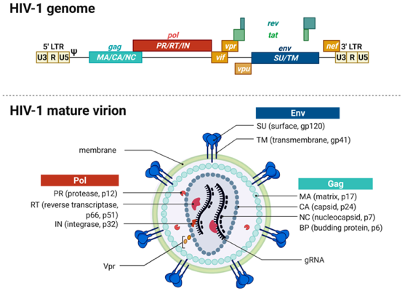
Early diagnosis relied on serology. The ELISA (enzyme-linked immunosorbent assay) was introduced in 1985, followed by Western blot confirmation. However, a window period existed between infection and antibody detection: the eclipse phase (virus not yet detectable by any assay, ~10 days), the seroconversion window (RNA positive, but antibody negative, ~10–24 days), and the incubation period (time from infection to clinical disease, years). Fourth-generation immunoassays (p24 antigen + antibody) later narrowed the window to ~2 weeks. Today, the CDC algorithm uses a 4th-gen test, followed by an HIV-1/2 differentiation immunoassay, and if necessary, an HIV-1 RNA test to resolve indeterminate results.

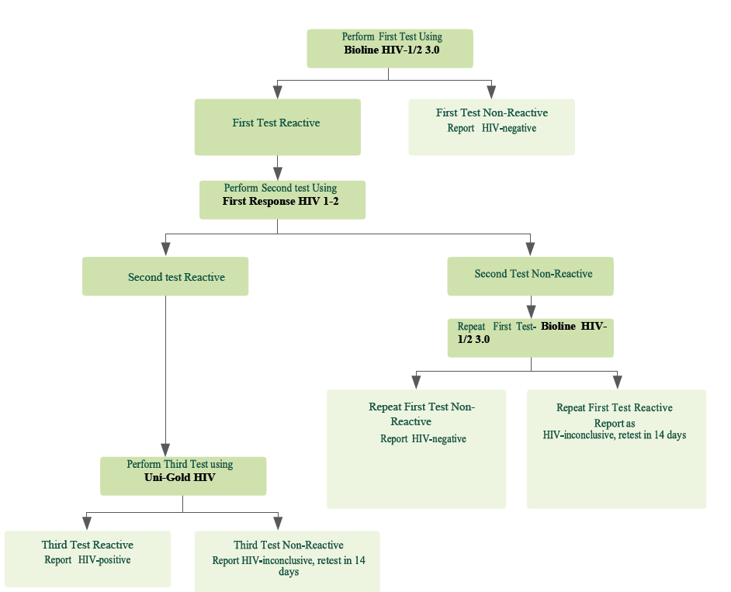

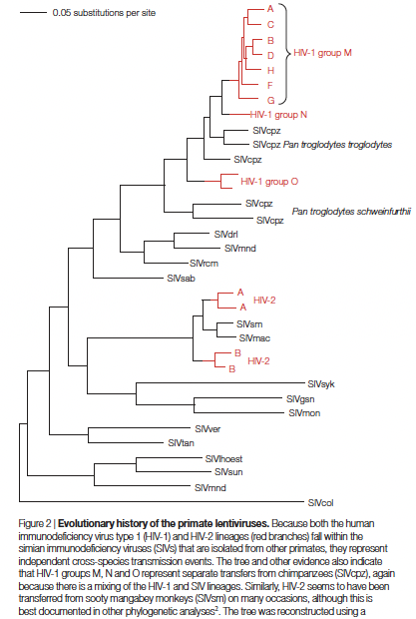
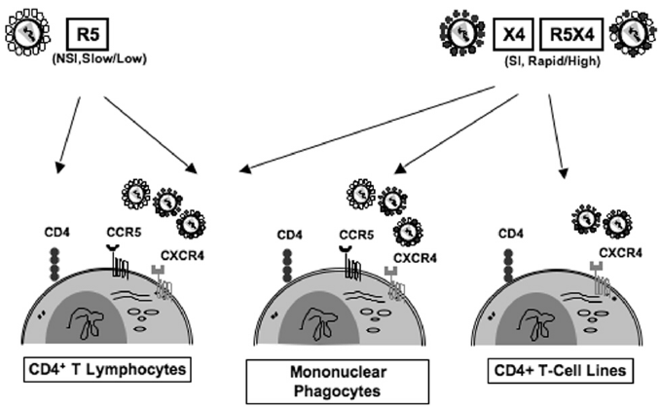

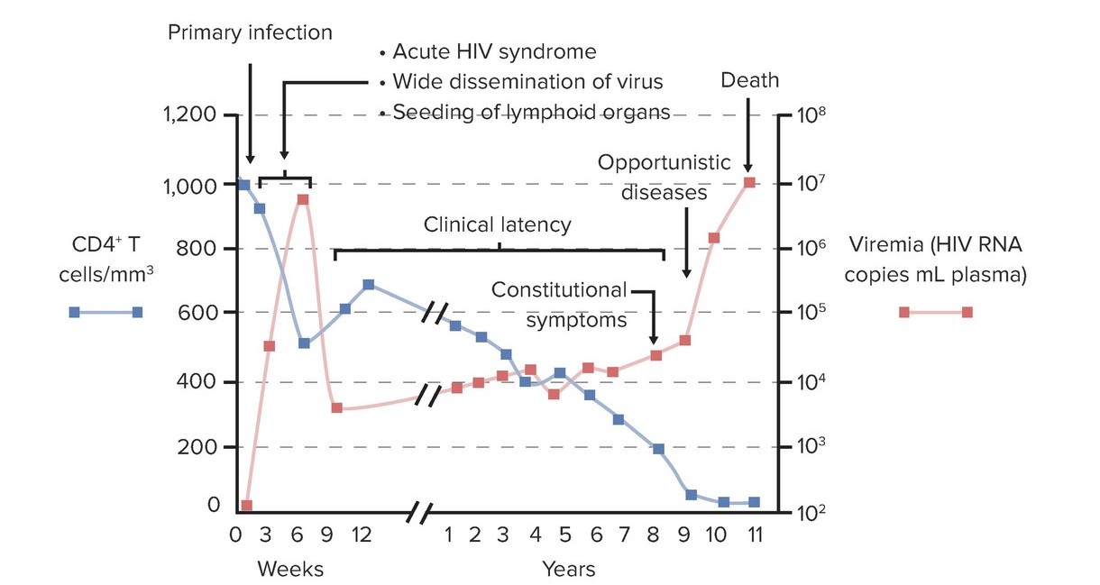

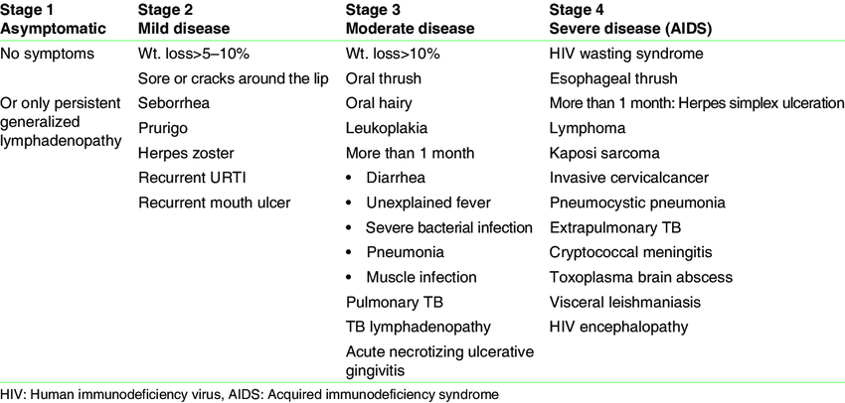
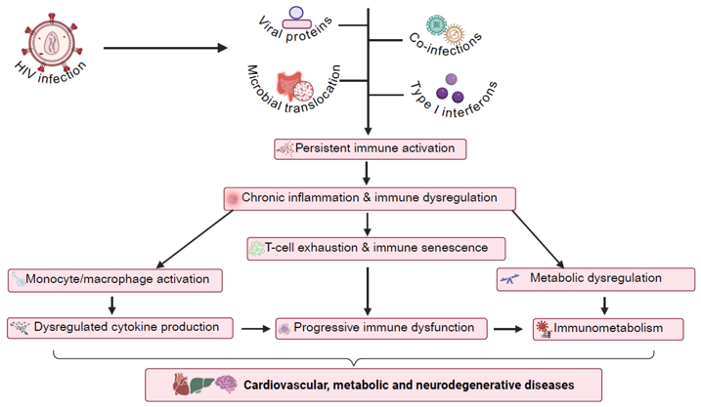

WHO clinical staging (1–4) was developed to assess disease severity based on clinical conditions (e.g., stage 1: asymptomatic or persistent generalized lymphadenopathy; stage 4: pneumocystis pneumonia, toxoplasmosis, etc.), with some correlates of CD4 count [ WHO Stage 1 (asymptomatic) CD4 >500, Stage 2 (mild) 350–499, Stage 3 (advanced) 200–349, Stage 4 (severe) <200 cells/µL.]. This staging system proved invaluable for guiding treatment initiation in resource-limited settings before universal treatment.

The First Breakthrough: Zidovudine (AZT)
AZT, a nucleoside analogue originally synthesized as anticancer agent, was shown to inhibit HIV reverse transcriptase in vitro in 1985. It became the first antiretroviral approved in 1987.
Key Trials and Evidence
Richman et al., NEJM 1987 (double-blind, placebo-controlled RCT; n=282 adults with AIDS/advanced ARC): AZT 250 mg PO q4h vs placebo.
- Outcome: 19 deaths placebo vs 1 AZT (P<0.001), fewer opportunistic infections, improved functional + immunologic markers. This established short-term clinical benefit & approval.
- Toxicity companion publication: Severe anemia (Hb <7.5 g/dL) in 24% AZT vs 4% placebo; neutropenia (<500/mm³) 16% vs 2%; multiple transfusions 21% vs 4%. These safety data immediately drove dose-reduction strategies.
- Initial administration: 250 mg q4h (1,500 mg/day) or 200 mg q4h
- Dose-reduction era: Multiple trials soon demonstrated that lower doses preserved efficacy while reducing hematologic toxicity:
  - ACTG reduced-dose RCT (NEJM 1990; n=524): Standard (250 mg q4h) vs low-dose (200 mg q4h then 100 mg q4h). Lower-dose strategy had superior 18-month survival and less anemia/neutropenia.
  - Dose-ranging pilot (NEJM 1990; n=67): 300 mg/day produced similar short-term virologic effects as 600/1,500 mg/day with less toxicity.
  - Asymptomatic trial ACTG 019 (NEJM 1990; n=1,338): AZT 500 mg/day delayed AIDS progression vs placebo: less hematologic toxicity than 1,500 mg/day.
  - By 1992, consensus was AZT 500–600 mg/day for symptomatic and asymptomatic patients with CD4 <500/mm³, with dose reduction or growth factors for cytopenias.

Why AZT First? HIV’s discovery allowed in-vitro culture and screening of existing nucleoside analogues. AZT, a thymidine analog, inhibited reverse transcriptase (RT) and could be rapidly repurposed. This set the stage for all subsequent NRTIs.

Limitations of AZT Monotherapy
- Resistance: Thymidine analogue mutations (TAMs) emerged, particularly K70R (first) and T215Y/F, often with M41L, D67N, L210W, K219Q. At the time, genotypic resistance testing was in its infancy; clinical suspicion of resistance was based on disease progression.
- Durability: Progression despite AZT was common; survival benefit was time-limited.
- Toxicity: Dose-limiting marrow suppression remained a major hurdle.

2. HIV Pathogenesis and Elite Controllers: Why Does the Immune System Fail?
Understanding HIV pathogenesis is crucial to appreciating why ART must be life-long. The virus preferentially infects CD4+ T cells, leading to progressive depletion. The latent reservoir is established within days of infection, primarily in resting memory CD4+ T cells, where the HIV genome integrates into host DNA but remains transcriptionally silent. This reservoir is undetectable to the immune system and not targeted by current antiretrovirals. Thus, even after years of complete viral suppression on ART, stably suppressed patients harbor an intact, replication-competent HIV genome, which rebounds within weeks if therapy is interrupted. This explains why ART is not curative + lifelong adherence is essential.

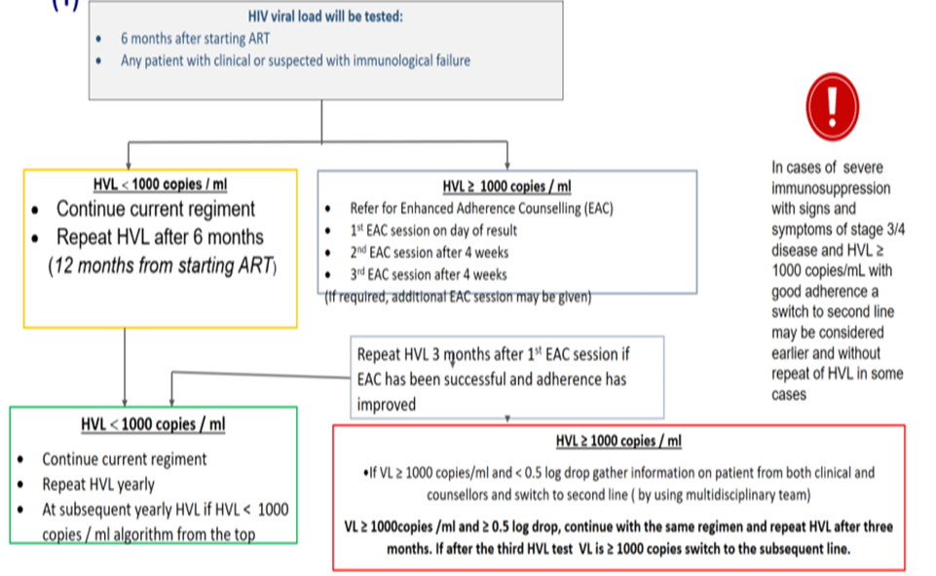
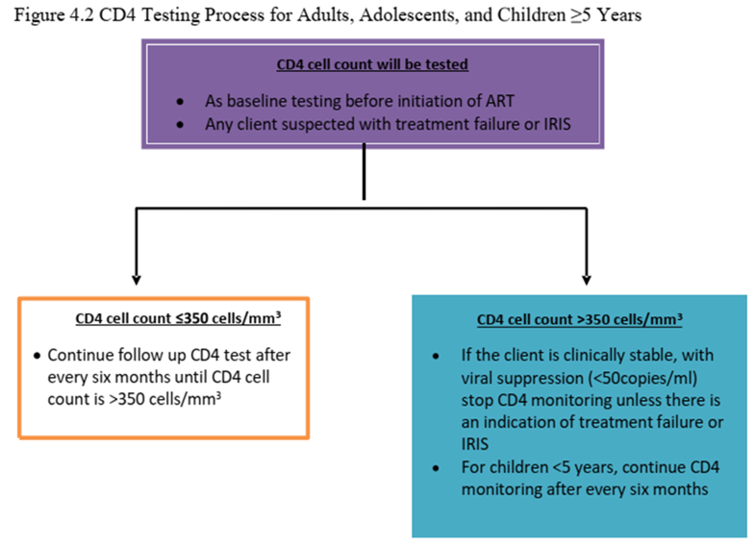
Natural Controllers: A tiny minority (<0.5%) of people with HIV can spontaneously control viremia without ART. Elite controllers maintain viral loads <50 copies/mL, while viremic controllers keep levels <2,000 copies/mL. This is associated with HLA class I alleles (HLA-B*57:01 and HLA-B*27), which present highly conserved viral epitopes to cytotoxic T lymphocytes, driving effective CD8+ T-cell responses. However, even elite controllers exhibit chronic immune activation, accelerated atherosclerosis, and higher rates of non-AIDS events compared to HIV-negative individuals. Moreover, many controllers eventually lose control. Therefore, current guidelines recommend ART for all controllers to reduce immune activation and prevent disease progression, a policy solidified by the START trial.

3. Expanding NRTI Armamentarium and Dual-NRTI Therapy (Late-1980s – Mid-1990s)

Why Change? AZT monotherapy clearly had limited durability. Resistance and toxicity forced the development of alternative nucleosides and the concept of combining them. New NRTIs and early Combinations, Didanosine (ddI), zalcitabine (ddC), stavudine (d4T), ABC (hypersensitivity in HLA-B*5701) and lamivudine (3TC) became available for sequential monotherapy or dual therapy.
Key Evidence for Dual NRTIs
- Cochrane IPD meta-analysis (6 RCTs; 2,904 progressed, 1,850 deaths): Adding ddI to AZT reduced progression (RR 0.74) and death (RR 0.72); adding ddC reduced progression (RR 0.86) + death (RR 0.87). Interpretation: Dual NRTI was better than monotherapy but still insufficient for durable suppression.
- Wellcome Resistance Study Collaborative Group (J Infect Dis 1996; RCT substudy): Initial AZT+ddI or AZT+ddC produced higher CD4 rises and more sustained HIV RNA declines than AZT alone, and AZT+ddI delayed time to AIDS event/death. However, it did not prevent emergence of AZT-resistant isolates.
- AZT + 3TC (JAMA 1996; RCT; n=129 ARV-naïve): 3TC 300 mg q12h + AZT 200 mg q8h vs AZT alone at 24 weeks. Outcome: Greater CD4 rise (+0.08 vs +0.02 ×10⁹/L) and larger viral load reduction (−1.33 vs −0.57 log10 copies/mL). 3TC resistance (M184V) emerged rapidly, but the combination demonstrated synergistic short-term benefits and led to the fixed-dose combination Combivir (AZT/3TC) in 1997.

Guidelines in the Dual-NRTI Era.
- 1993 State-of-the-Art Conference (JAMA): Based on trials of AZT, ddI, ddC, a scenario-based approach was recommended. Zidovudine remained first-line when treatment was started, with combination nucleoside therapy increasingly preferred.
- IAS-USA 1996: Treatment decisions were tied to CD4 count, clinical status, and plasma HIV RNA. Preferred initial regimens were NRTI combinations (e.g., AZT+ddI or AZT+3TC). Protease inhibitors were “probably best reserved” for patients at higher risk of progression, due to limited long-term data, complexity, and toxicity concerns.

Emergence of Resistance Testing: As treatment options expanded, the need to understand viral mutations driving drug failure became apparent. Genotypic resistance testing (Sanger sequencing of the RT and protease genes) became clinically available in the late 1990s. It identifies specific mutations (e.g., M184V for 3TC, TAMs for AZT) and, using rule-based algorithms (e.g., Stanford HIVdb), interprets the susceptibility profile. Phenotypic testing (e.g., PhenoSense, Antivirogram) directly measures the concentration of drug needed to inhibit 50% of viral replication (IC50) in cell culture, providing a “fold-change” in susceptibility. While phenotypic testing is more intuitive, it is slower and costlier; genotyping remains first-line. Virtual phenotyping (e.g., VircoTYPE) compares a patient’s genotype to a database of genotype-phenotype pairs to predict drug activity. Today, deep sequencing (next-generation sequencing) can detect minority variants comprising as little as 1% of the viral population, missed by Sanger sequencing. Resistance testing is now recommended at baseline (RT-protease; integrase only if risk factors) and in all virologic failure.

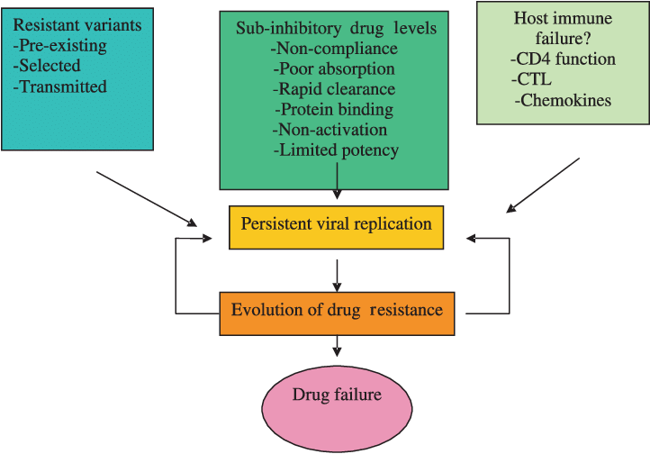
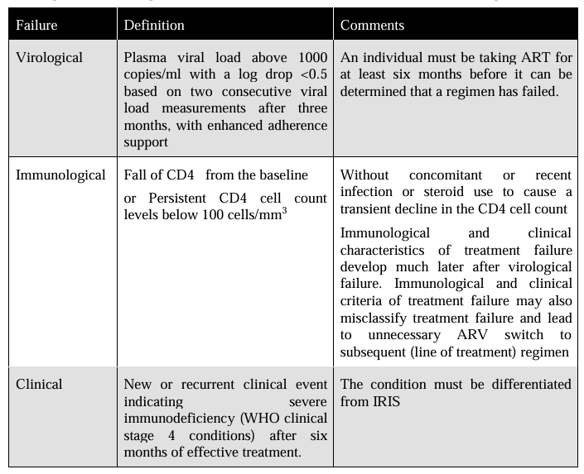
The Unmet Need: Dual NRTI therapy could not achieve deep or durable viral suppression. Resistance emerged quickly, and clinical progression continued. The stage was set for a third drug class.

4. The HAART Era: Protease Inhibitors (1995 – Early 2000s)

The Discovery of Protease Inhibitors : HIV protease, an essential aspartyl protease, was identified and its crystal structure solved. Structure-based drug design yielded peptidomimetic transition-state analogues that fit the active site, blocking cleavage of Gag and Gag-Pol polyproteins. This prevents virion maturation—particles are produced but are non-infectious. The first approved PIs were saquinavir, ritonavir, indinavir, and nelfinavir (1995–1997).

Why PIs Were Revolutionary
- Unprecedented viral load declines (1.5–2.0 log10 with ritonavir/indinavir vs 0.5–0.7 log10 with NRTIs alone).
- Enabled “undetectable” viremia in combination with 2 NRTIs—the birth of Highly Active Antiretroviral Therapy (HAART).

The Landmark Trial That Changed Practice
- ACTG 320 (Hammer et al., NEJM 1997; double-blind RCT; n=1,156 adults with CD4 ≤200/µL, prior ZDV exposure): ZDV (or d4T) + 3TC ± indinavir 800 mg q8h. Primary outcome (AIDS progression/death): 6% with triple therapy vs 11% with dual therapy; HR 0.50 (95% CI 0.33–0.76, P=0.001). Mortality: 1.4% vs 3.1%; HR 0.43 (P=0.04). Impact: First definitive clinical-endpoint proof that adding a PI to 2 NRTIs dramatically reduced disease progression and death.
- Gulick et al., NEJM 1997 (RCT; n=97): Indinavir + ZDV + 3TC achieved HIV RNA <500 copies/mL in 90% at week 24 vs 0% with ZDV+3TC. This virologic proof-of-concept complemented ACTG 320.

Resulting Guideline Shifts
- 1998 DHHS/Kaiser Guidelines: Recommended “aggressive” initial therapy aiming for maximal viral suppression, generally a PI + 2 NRTIs. Treatment was offered to asymptomatic patients with CD4 <500 cells/mm³; for CD4 >500, decisions were guided by plasma HIV RNA and patient readiness. Viral load monitoring (baseline, 2–8 weeks, then every 3–4 months) became standard.
- IAS-USA 1996 → 1998: Moved toward potent triple therapy for most eligible patients.

Drug-Disease Interactions in the PI Era
PIs, particularly when boosted with ritonavir or cobicistat, are potent inhibitors of CYP3A4 and other metabolic pathways, leading to numerous clinically significant interactions:
- Rifamycins (TB): Rifampicin drastically reduces PI levels; PIs are generally contraindicated with rifampicin. Rifabutin can be used with dose adjustments.
- Anticonvulsants: Carbamazepine, phenytoin, phenobarbital induce CYP3A4, lowering PI concentrations and risking virologic failure. Alternative anticonvulsants (levetiracetam, lacosamide) are preferred.
- Contraception: PIs may alter levels of ethinyl estradiol and progestins, potentially reducing contraceptive efficacy and increasing hormone-related side effects. Additional barrier contraception is advised.
- Statins: Simvastatin and lovastatin are contraindicated due to rhabdomyolysis risk; atorvastatin and rosuvastatin can be used with caution.
- Dialysis: Most PIs are highly protein-bound and not significantly removed by hemodialysis; no dose adjustments are typically needed. However, boosted regimens may require attention to fluid overload (ritonavir oral solution contains alcohol).
These interactions added complexity to management of aging patients (since drugs suppressed virus well, patient lived longer and could have other comorbidities).

The Global Impact of PIs: Mortality and morbidity plummeted in resource-rich settings. In the HIV Outpatient Study and pediatric cohorts, PI-containing combination therapy was independently associated with reduced mortality (adjusted HR 0.33). Population-level data from the ART Cohort Collaboration show all-cause mortality fell from 16.8/1000 PY (1996–1999) to 7.9/1000 PY (2016–2020) as regimens and initiation criteria improved.

The Downside of PIs
- Metabolic toxicity: Dyslipidemia (via proteasomal ApoB effects, ER stress → CHOP → lipogenesis), insulin resistance (direct GLUT4 inhibition by indinavir, impaired adipocyte differentiation), and lipodystrophy.
- Organ toxicity: Indinavir nephrolithiasis/crystal nephropathy; hepatotoxicity ( ritonavir).
- Drug–drug interactions: As described, CYP3A4 inhibition became both a blessing (ritonavir boosting) and a curse (polypharmacy). & Complex dosing/food requirements and high pill burden.

Clinical Monitoring During the PI Era
- Viral load every 2–8 weeks initially, then every 3–4 months.+ CD4 count regularly.
- Metabolic monitoring and hepatic panels, esp. with co-infection + for drug interactions.
Despite these challenges, PIs established the principle that 3 potent drugs could change HIV poggression. However, search for more tolerable, simpler, + potent regimens continued.

5. The NNRTI Branch: A Parallel Path to HAART Simplicity (Mid-1990s – 2010s)

Discovery and Mechanism: Non-nucleoside RT inhibitors (NNRTIs) are allosteric inhibitors that bind a hydrophobic pocket ~10 Å from the RT active site, distorting the catalytic geometry and displacing the primer terminus. They are specific for HIV-1 RT. Nevirapine (1996) and efavirenz (1998) became cornerstones of global ART.

Key Trials Establishing NNRTI-Based HAART
- ACTG 241 (Ann Intern Med 1996; RCT; n=398 with nucleoside experience): Nevirapine + ZDV + ddI vs placebo + ZDV + ddI. Outcome: Demonstrated virologic/immunologic improvement with addition of an NNRTI, supporting triple therapy.
- NEJM 2003 strategy trial (RCT; n=620 treatment-naïve): Sequential 3-drug regimens including ZDV/3TC/EFV vs PI-containing or alternative NRTI strategies. Outcome: EFV-based regimen had superior time to suppression and delayed regimen failure compared to nelfinavir-based or ddI/d4T-based approaches, establishing 2 NRTIs + EFV as a leading first-line strategy.
- 2NN Study (Lancet 2004; RCT; n=1,216): Compared NVP+2NRTIs, EFV+2NRTIs, NVP+EFV+2NRTIs. Outcome: NVP and EFV were both viable anchors; dual-NNRTI arm did not provide advantage and was not adopted due to cross-resistance and additive toxicity.
- ACTG 5095 (NEJM 2004; RCT; n=1,147): Triple-NRTI (ABC/ZDV/3TC) vs EFV-containing regimens. Triple-NRTI arm was virologically inferior, affirming the necessity of a potent third agent (NNRTI or PI).

Why NNRTIs Dominated Global First-Line
- Comparable efficacy: A systematic review/meta-analysis of 29 RCTs (n=9,047) found no difference between NNRTI and boosted-PI initial therapy for death/progression (RR 1.03) or 48-week suppression (RR 1.03).
- Programmatic advantages: Once-daily, single-tablet fixed-dose combinations (e.g., TDF/FTC/EFV) were scalable, cheaper, and simpler than PI regimens.
- Result: EFV-based ART became backbone of WHO public-health programs for >15 years, with PIs reserved for second-line.

NNRTI-Specific Drug Interactions: NNRTIs are CYP3A4 inducers (nevirapine, efavirenz) or substrates/inhibitors (etravirine, rilpivirine), creating unique challenges:
- Contraception: Efavirenz reduces ethinyl estradiol and progestin levels, potentially compromising hormonal contraceptive efficacy; reliable alternatives (IUDs, medroxyprogesterone) are recommended. Nevirapine has less impact.
- TB therapy: Rifampicin induces CYP3A4 and can significantly lower EFV levels; however, EFV remains a preferred anchor with rifampicin (no dose adjustment usually required). Nevirapine is not recommended with rifampicin due to high risk of toxicity and subtherapeutic levels. Rilpivirine is contraindicated.
- Anticonvulsants: Similar to PIs, inducers like carbamazepine reduce NNRTI levels
- Dialysis: Efavirenz is highly protein-bound and not dialyzed; no dose change. Nevirapine is partially dialyzed; an additional dose post-dialysis is suggested by some guidelines.
- Low genetic barrier: Single mutations (e.g., K103N, Y181C, G190A) can confer high-level resistance. Among first-line NNRTI failures, resistance emerged in ~53% vs 0.9% for boosted PIs.
- Transmitted drug resistance (TDR): A global meta-analysis (2000–2013, 50,870 sequences) showed rising NNRTI resistance, with K103N, Y181C, G190A, and K101E accounting for >80% of NNRTI-associated TDR.
- Though M184V/I point mutations confer high level resistance (>100 fold) to 3TC or FTC, an essential component most combination regimens, this mutation has high fitness costs, enhancing viral fidelity and resensitizing viruses to ZDV, d4T and TDF
- Pretreatment NNRTI resistance in LMICs (Lancet Infect Dis 2018; 358 datasets, n=56,044): By 2016, prevalence in southern Africa reached 11.0%, exceeding WHO’s threshold for shifting away from NNRTI-first-line.
- Tolerability: Neuropsychiatric effects of EFV (vivid dreams, suicidality in pooled analysis of 4 ACTG trials), rash and hepatotoxicity with NVP (especially in women with CD4 >250 and men with CD4 >400).
- These limitations set the stage for the next revolution: integrase inhibitors.

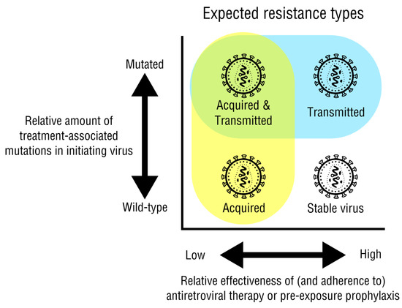
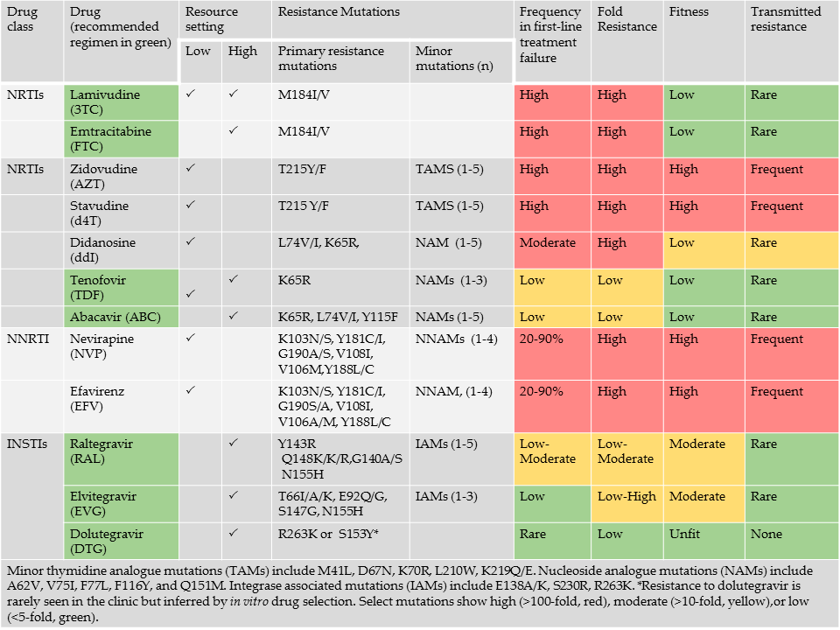

6. The INSTI Era: High Barrier, High Tolerability, Universal ART (2007–Present)

Discovery and Mechanism: Integrase strand-transfer inhibitors (INSTIs) were designed to chelate the two Mg²⁺ ions in the integrase active site and block the strand-transfer step of viral DNA integration (interfacial inhibition of the intasome). First-generation agents (raltegravir, elvitegravir) entered practice in the late 2000s. Second-generation INSTIs (dolutegravir, bictegravir, cabotegravir) improved resistance barrier and pharmacokinetics.

The Evidence That Drove the INSTI Preference

A. Superior Efficacy and Tolerability
- SINGLE (NEJM 2013; double-blind phase 3 RCT; n=833 treatment-naïve): DTG + ABC/3TC vs EFV/TDF/FTC. Primary endpoint: HIV RNA <50 copies/mL at week 48: 88% vs 81% (P=0.003). Faster suppression (median 28 vs 84 days), fewer discontinuations due to AEs (2% vs 10%), and no detectable INSTI resistance in the DTG arm.
- FLAMINGO (2013–2014) was a randomized, open-label phase III trial in treatment-naïve HIV patients comparing dolutegravir vs darunavir/ritonavir + 2 NRTIs. At week 48, viral suppression (<50 copies/mL) was ~90% with dolutegravir vs ~83% with darunavir/ritonavir, demonstrating superiority with better tolerability.
- SAILING (Lancet 2013; phase 3 RCT; n=719 treatment-experienced, INSTI-naïve): DTG vs raltegravir, both with optimized background. DTG superior at week 48 (HIV RNA <50: 71% vs 64%; P=0.03), with fewer discontinuations and no emergent resistance in DTG arm vs 5% with RAL. Established DTG's higher barrier even in non-naïve populations.
- Network meta-analysis informing WHO guidelines (Lancet HIV 2016; 71 RCTs, n=34,032): DTG had higher odds of 48-week suppression vs EFV (OR 1.87) and fewer discontinuations (OR 0.26). Later expanded analysis (EClinicalMedicine 2020) added 96-week data (DTG vs EFV OR 1.94) and DTG’s protective effect against drug resistance.
- ADVANCE (NEJM 2019; open-label phase 3 RCT; n=1,053 in South Africa): DTG + FTC + (TAF or TDF) vs TDF/FTC/EFV. Week-48 suppression: DTG arms 84–85% vs EFV 79% (noninferior). *No INSTI resistance detected. Weight gain was notably higher with DTG + TAF/FTC (mean 6.4 kg) vs EFV (1.7 kg), introducing modern metabolic concern.*
- NAMSAL (Lancet HIV 2019; open-label phase 3 RCT; n=613 in Cameroon): DTG + TDF/3TC vs EFV400 + TDF/3TC. Week-48 suppression: 74.5% vs 69.0% (noninferiority met); fewer virologic failures with DTG (3 vs 16), no acquired DRMs in DTG failures. Weight gain and obesity incidence higher with DTG (12.3% vs 5.4%).

B. Two-Drug Regimens: Simplification Without Sacrifice (Later on)
- GEMINI-1 & GEMINI-2 (Lancet 2019; identical phase 3 RCTs; n=1,433 treatment-naïve with HIV RNA ≤500,000): DTG + 3TC vs DTG + TDF/FTC. Week-48 suppression 91% vs 93% (noninferior). No emergent resistance in either arm. Established DTG/3TC as a first-line option in appropriate patients.
- TANGO (Clin Infect Dis 2020; phase 3 RCT; n=741 suppressed on TAF-based 3-drug regimen): Switch to DTG/3TC vs continue TAF-based regimen. Week-48 suppression 93% vs 93% (noninferior). No resistance. Supports simplification in stable patients.
- These data, combined with meta-analytic evidence (Lancet HIV 2016, 21 trials) showing similar overall failure but higher risk with baseline VL >100,000 copies/mL (RR 1.24) and more mutation selection (OR 2.11), shape a “selected patients only” approach for 2-drug therapy.

C. Second-Line Efficacy and Simplification
- EARNEST (NEJM 2014; open-label RCT; n=1,277 with first-line failure in sub-Saharan Africa): PI (lopinavir/r) + 2 NRTIs vs PI + RAL vs PI monotherapy. Outcome: PI + 2 NRTIs was standard; PI monotherapy inferior. This reinforced boosted-PI backbone for second-line.
- NADIA (Lancet HIV 2022; factorial noninferiority RCT; n=464 failing NNRTI-based first-line): DTG vs DRV/r and TDF vs AZT in second-line. Week-48 HIV RNA <400: DTG 90.2% vs DRV/r 91.7% (noninferior); TDF noninferior to AZT. DTG-based second-line was effective even with extensive NRTI resistance.
- 2SD trial (Kenya, RCT; virologically suppressed on second-line PI): Switching to DTG-based regimen was noninferior to continuing boosted PI, with no resistance at failure.

D. Additional INSTI Advantages
- Resistance barrier: DTG/BIC are considered high-barrier, though signature mutations exist. R263K (low-level), G118R (moderate-high), and the Q148H/R/K ± G140S/E138K pathway (highest cross-resistance to all INSTIs) can emerge, especially with functional monotherapy or prolonged failure. Baseline integrase genotyping is not routinely recommended for treatment-naïve patients because transmitted INSTI resistance remains rare (<1%), but it is essential for those with known INSTI exposure (e.g., cabotegravir PrEP breakthrough) or failure on an INSTI.
- Drug-drug interactions: Far fewer than boosted PIs, but vigilance is still needed:
  - TB (rifampicin): DTG must be doubled to 50 mg BID when co-administered with rifampicin, due to UGT1A1 induction. BIC and EVG are not recommended with rifampicin.
  - Anticonvulsants: Carbamazepine, phenytoin, oxcarbazepine induce UGT1A1 and CYP3A4, reducing DTG levels; DTG should be administered 50 mg BID if co-administration unavoidable. BIC is not recommended.
  - Contraception: INSTIs (especially DTG, BIC) have no clinically significant effect on hormonal contraceptives, making them preferable for women of reproductive potential.
  - Dialysis: DTG and BIC require no dose adjustment in renal impairment, including dialysis. TAF can be used in mild-moderate renal disease; TDF requires dose adjustment when CrCl <50 mL/min. Thus, INSTI + TAF/FTC now offers a safe regimen for patients with end-stage renal disease.
- Weight gain signal: DTG and TAF are associated with greater weight gain than EFV/TDF. Mechanistic studies suggest direct adipose effects (adipocyte hypertrophy, reduced beiging, mitochondrial dysfunction) and “unmasking” of weight-suppressive effects of EFV/TDF. This has shifted monitoring toward cardiometabolic surveillance.

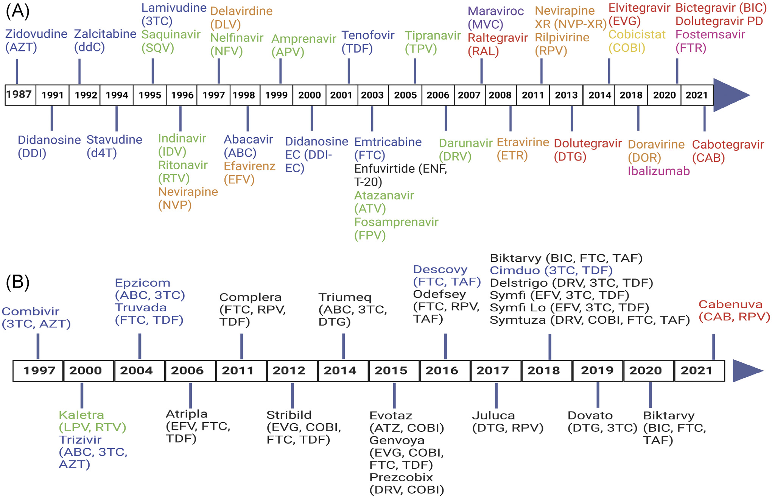

7. Guideline Evolution: From “When to Start” to “Treat All”
- START (INSIGHT) trial (NEJM 2015; RCT; n=4,685 asymptomatic adults with CD4 >500/µL): Immediate ART vs deferred until CD4 <350/µL or AIDS.
Outcome: Composite serious AIDS/non-AIDS events or death: HR 0.43 (P<0.001). This provided the missing evidence for universal treatment irrespective of CD4.
- TEMPRANO ANRS 12136 (NEJM 2015; 2×2 factorial RCT; n=2,056 in Côte d’Ivoire): Early ART reduced severe illness/death (aHR 0.56) and IPT independently reduced severe outcomes (aHR 0.65). Supported treat-all and TB prevention integration.
- IAS-USA 2014: Recommended ART for all. By 2016, INSTI + 2 NRTIs became preferred initial therapy for most adults. The 2024 update (JAMA 2025) codifies BIC- or DTG-based regimens as first-line, with specific guidance on rapid start, 2-drug regimens (e.g., DTG/3TC for selected patients), long-acting injectables, and metabolic monitoring.
- WHO: After the network meta-analyses, DTG + TDF/FTC (or 3TC) was endorsed as the preferred first-line regimen globally, with EFV400 as an alternative.

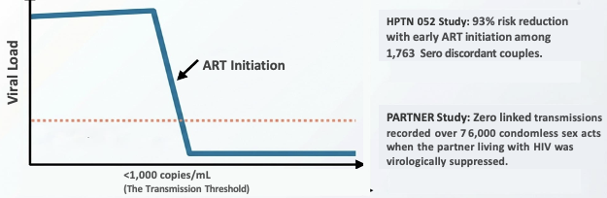
The “U=U” Revolution: Sustained viral suppression on any ART, including INSTI- or PI-based regimens, renders sexual transmission near zero. HPTN 052 (NEJM 2011, serodiscordant couples) demonstrated HR 0.07 for linked transmission with early ART, and no transmissions occurred when the index partner was stably suppressed. INSTIs enhance this by achieving faster, durable suppression with better tolerability.

8. Immune Reconstitution Inflammatory Syndrome (IRIS)
As potent ART restores immune function, some patients experience a paradoxical worsening of pre-existing infections or an unmasking of subclinical infections—IRIS. Two forms exist: paradoxical IRIS (recurrence or worsening of a treated OI, e.g., TB, cryptococcal meningitis) and unmasking IRIS (first appearance of a previously undiagnosed OI). Risk factors include a low CD4 nadir (<50–100 cells/µL), high baseline viral load, and initiation of ART close to OI treatment (within 2–4 weeks). IRIS reflects a recovering immune system mounting an exaggerated inflammatory response to pathogen antigens. Fever, lymphadenopathy, worsening pulmonary/CNS lesions, uveitis/retinitis; unmask HBV/HCV.
Diagnosis: Major—typical OI/malignancy worsening on ART + viral load drop >1 log₁₀.
Minor—↑CD4, ↑ pathogen-specific response (PPD), spontaneous improvement on ART.
Rule: Both major or 1 major + 2 minor. Management generally involves continuing ART and the OI-specific therapy; severe cases (e.g., CNS IRIS, airway compromise) may require corticosteroids (prednisone 1–1.5 mg/kg/day). The decision to start ART early vs delayed after OI therapy balances IRIS risk against mortality from delayed immune recovery—early ART is recommended for most OIs, except in cryptococcal meningitis where a 2–4 week deferral may reduce IRIS-related mortality.

9. Adherence: The Keystone of Suppression
Even the best regimens fail without consistent adherence. Early HAART required near-perfect adherence (>95%) to maintain suppression and prevent resistance, especially for unboosted PIs and NNRTIs. Modern INSTI-based regimens are more forgiving, but suboptimal adherence still risks virologic failure and emergent resistance, particularly in dual-drug regimens or functional monotherapy situations.

Measurement and Interventions : Self-report (convenient but overestimates), and objective drug levels (dried blood spots). The WHO adherence intervention meta-analysis (Lancet HIV 2017; 85 trials, n=16,271) found that SMS reminders improved adherence (OR 1.48 in LMICs) and viral suppression. Multi-component strategies (counseling, cognitive-behavioral therapy, peer support) showed modest benefit but often waned over time. Integration of adherence support into routine clinic care is now standard.

10. Prophylaxis and Presumptive Treatment of Opportunistic Infections
Even in the treat-all era, patients presenting with advanced HIV (CD4 <200) remain at high risk for OIs. Prophylaxis and presumptive treatment are critical in comprehensive HIV care.
- Pneumocystis jirovecii pneumonia (PCP): TMP-SMX double-strength daily or three times weekly for all with CD4 <200 cells/µL (or <14% in children). Can discontinue when CD4 >200 for >3 months on ART.
- Tuberculosis (TB): Isoniazid preventive therapy (IPT) for 6–9 months in all people with HIV without active TB, regardless of CD4, in high-burden settings. The TEMPRANO trial confirmed IPT independently reduced severe illness/death (aHR 0.65). TST or IGRA screening is recommended where available; in resource-limited settings, symptom screening alone may guide IPT.
- Cryptococcal meningitis: In areas with high prevalence, serum cryptococcal antigen (CrAg) screening is recommended for those with CD4 <100 cells/µL. CrAg-positive patients should undergo lumbar puncture to rule out meningitis and receive preemptive fluconazole (800 mg/day for 2 weeks, then 400 mg/day for 8 weeks) if asymptomatic, followed by secondary prophylaxis.
- Mycobacterium avium complex (MAC): Azithromycin 1,200 mg weekly or clarithromycin for CD4 <50 cells/µL, when not on effective ART.
- Toxoplasmosis: No universal primary prophylaxis, but TMP-SMX for PCP also protects against toxoplasmosis. Patients with CD4 <100 and positive Toxoplasma IgG should receive TMP-SMX.
- Presumptive treatment: In settings without immediate diagnostic capability, WHO recommends syndromic management—e.g., empiric therapy for PCP, TB, or cryptococcal meningitis based on clinical presentation—followed by rapid ART initiation.

11. Modern Management Algorithms: From HAART to Personalized ART

Monitoring Refinements (IAS-USA 2024)
- HIV RNA: At 4–6 weeks after start, then q3 months until suppressed; subsequently q6 months; after >5 years of stable suppression, can extend to annually.
- CD4: Baseline and q6 months until >250/µL for ≥1 year, then discontinue routine monitoring unless virologic failure or immunosuppression.
- Resistance testing: RT-protease genotype at baseline and at virologic failure (HIV RNA >200 copies/mL on 2 measurements). Integrase genotype at baseline only if specific risk (cabotegravir PrEP exposure, suspected INSTI-resistant source). In failure on INSTI, add integrase genotyping. Next-generation sequencing is increasingly used to detect minority variants, which may impact regimen selection in complex cases.
- Cardiometabolic surveillance: Weight/BMI q6 months with INSTI/TAF; blood pressure every visit; diabetes screening annually. This reflects the shift from PI lipid toxicity to INSTI/TAF weight concerns.
- Safety labs: Renal, hepatic, and urine monitoring based on backbone (e.g., TDF: urine glucose/protein at baseline and annually).

Switch and Simplification Strategies
- Two-drug oral regimens: DTG/3TC (GEMINI, TANGO) is approved for initial therapy when HIV RNA <500,000 copies/mL, no HBV, and no 3TC resistance. A meta-analysis shapes a “selected patients only” approach.

- Long-acting injectable CAB/RPV:
  - ATLAS (NEJM 2020; switch-suppressed; n=616): CAB/RPV-LA monthly vs continued oral ART. HIV RNA ≥50 at wk48: 1.6% vs 1.0% (noninferior).
  - FLAIR (NEJM 2020; induction → switch; n=566): 2.1% vs 2.5% (noninferior).
  - ATLAS-2M (phase 3b): Q8W noninferior to Q4W.
  - CARES (Africa; phase 3b; n=512): Q8W VL <50 at wk48 96% vs 97% (noninferior); sustained at wk96.
  - LATITUDE (NEJM 2026; adherence-challenged): Monthly CAB/RPV-LA after suppression reduced regimen failure vs standard oral care (22.8% vs 41.2%). Key caveat: Virologic failure is uncommon (~1% in suppressed switch), but when it occurs, emergent INSTI resistance (often with DTG cross-resistance) is seen in 41–71% of genotyped failures. Strict monitoring (VL at 1 month, then q3 months ×1 year) and bridging plans for missed doses are essential.

- Islatravir (ISL) and maturation inhibitors:
  - ISL (NRTTI) has shown potent, long-acting potential (phase 3 switch trials: DOR/ISL noninferior) but dose-dependent lymphopenia halted early development, now revived at lower doses. It is a first-in-class nucleoside reverse transcriptase translocation inhibitor (NRTTI). Unlike conventional NRTIs, ISL-triphosphate incorporates into the nascent viral DNA and then blocks RT translocation—the enzyme’s movement along the template—trapping the complex in a non-productive state and producing delayed chain termination. This, combined with an exceptionally long intracellular half-life, enables potent antiviral activity at very low daily or even weekly doses. Higher-dose development was paused due to dose-dependent declines in total lymphocytes and CD4+ T cells, but the lower 0.25 mg dose did not trigger these safety signals, allowing the program to resume. Its extended pharmacokinetics also support once-weekly oral dosing with lenacapavir, which maintained high suppression in phase 2, making it a potential long-acting oral alternative to injectables.
  - Maturation inhibitors (GSK3640254) are in phase 2b (DOMINO trial: comparable to DTG) but not yet practice-ready.

The Latent Reservoir: Why We Cannot Cure HIV
Despite complete viral suppression on ART, the integrated HIV genome persists in resting CD4+ T cells and possibly other sanctuaries (macrophages, microglia). This latent reservoir is established within days of infection and decays with a half-life of ~44 months, meaning natural eradication would take >70 years. The reservoir is not affected by current ART, which only blocks new infection of cells. Thus, treatment interruption almost universally leads to viral rebound, even after decades of suppression. This reality underlies the need for lifelong adherence and drives cure research strategies such as “shock and kill” (latency reversal agents plus immune clearance), “block and lock” (permanent silencing), gene therapy (CCR5 knockout), and broadly neutralizing antibodies.

12. Novel Mechanisms for Multidrug-Resistant HIV
When standard classes fail, new drugs with orthogonal mechanisms are essential. IAS-USA 2024 recommends using agents like ibalizumab, fostemsavir, or lenacapavir to construct ≥2 fully active drugs.
- Lenacapavir (capsid inhibitor): Binds the capsid hexamer interface, hyperstabilizing the lattice → capsid failure → pre-integration block.
  - CAPELLA (NEJM 2022; phase 3; n=72 MDR HIV): During 14-day functional monotherapy, ≥0.5 log10 VL decline in 88% vs 17% placebo. With OBR, week-26 HIV RNA <50 in 81–83%. Emergent capsid resistance (e.g., M66I) occurred in 8 participants. Week-104 snapshot: 62% suppressed, 82% when excluding discontinuations.
- Fostemsavir (gp120 attachment inhibitor): Prodrug that binds gp120, blocking CD4 attachment.
  - BRIGHTE (NEJM 2020; phase 3; n=371 MDR HIV): Day-8 VL decline −0.79 log10 vs −0.17 placebo. Week-48 <40 copies/mL in 54% (with ≥1 active option) and 38% (no options). gp120 escape substitutions in 43% of failures.
- Ibalizumab (post-attachment anti-CD4 mAb): Binds CD4 noncompetitively, block entry.
  - TMB-301 (NEJM 2018; single-arm; n=40 MDR): 83% achieved ≥0.5 log10 decline at day 14; week-25 <50 in 43%. Reduced susceptibility emerged in 9/10 failures.
These agents represent salvage cornerstones, but their real-world impact is constrained by parenteral administration (ibalizumab, lenacapavir) or BID dosing with modest overall suppression rates, depending on background activity.

13. Prevention: PrEP and PEP in the Modern Era

Mechanism of Prevention: Antiretrovirals prevent infection by maintaining inhibitory drug levels in susceptible tissues and cells, blocking reverse transcription (tenofovir/FTC) or integration (cabotegravir) before a disseminated infection is established. The goal is to protect during the eclipse phase when infection is still localized and potentially abortive.
PrEP for Sexual Exposure:
- Oral TDF/FTC:
  - Daily dosing has evidence across all exposure routes. In the iPrEx trial, conducted among cisgender men who have sex with men (MSM) and transgender women, daily oral TDF/FTC reduced HIV acquisition versus placebo (RR approximately 0.56 overall), with substantially greater protection among participants with high adherence and detectable drug levels.
  - Daily, evidence across all exposure routes. Meta-analysis RR vs placebo 0.46; with ≥70% adherence, RR 0.27. The “2-1-1” on-demand schedule (2 tablets 2–24 hours before sex, then 1 tablet 24h and 48h after) for anal sex only (IPERGAY trial RR 0.14).
  - PARTNERS PrEP (2010–2013, RCT, double-blind, placebo-controlled): HIV-negative partners in serodiscordant heterosexual couples (Kenya/Uganda); daily TDF vs TDF/FTC vs placebo with serial HIV testing and adherence monitoring. Partners PrEP Study ↓ HIV acquisition significantly (strong adherence–efficacy relationship; TDF/FTC > TDF), with reduced protection when drug levels were low. Limitation: intensive trial follow-up, stable couples, and high adherence support reduce generalizability to routine real-world settings.
- TAF/FTC:
  - DISCOVER (NEJM 2020; double-blind phase 3 RCT; n=5,387 MSM/TGW): TAF/FTC vs TDF/FTC. HIV incidence 0.16 vs 0.34 per 100 PY (IRR 0.47, noninferior). Bone and renal safety biomarkers favored TAF. TAF/FTC is now approved for PrEP in MSM/TGW, but not for cisgender women due to lower vaginal tissue levels.
- Long-acting cabotegravir:
  - HPTN 083 (NEJM 2021; n=4,566 MSM/TGW): Incidence 0.41 vs 1.22/100 PY; HR 0.34.
  - HPTN 084 (Lancet 2022; n=3,224 women): Incidence HR 0.12 vs TDF/FTC.
Limitation: Injection-site reactions (81% in HPTN 083), and risk of INSTI resistance with breakthrough infections detected late.
- Lenacapavir (q6 monthly):
  - PURPOSE-1 (NEJM 2024; n=5,338 cisgender women): 0 infections over 52 wks.
  - PURPOSE-2 (NEJM 2025; n=3,265 men/gender-diverse): Incidence 0.10/100 PY vs 0.93/100 PY on F/TDF (IRR 0.11). Caveat: Injection-site reactions; potential for capsid resistance if infection occurs.
PEP:
Start as soon as possible within 72 hours; 28-day course. CDC 2025 preferred: BIC/FTC/TAF or DTG + (TAF or TDF) + (FTC or 3TC). WHO suggests 2-drug acceptable, 3-drug preferred, without differentiating exposure type to simplify access. Transition to PrEP immediately after if ongoing risk.

14. Summary Timeline of Key Guidelines and Trials
Year | Guideline/Trial | Core Contribution
1987 | AZT approved (Richman NEJM) | First antiretroviral; monotherapy era begins.
1996 | IAS-USA | CD4/viral load-guided initiation; dual NRTI preferred, PIs reserved for high risk.
1997 | ACTG 320 | PI + 2 NRTIs reduces AIDS/death vs dual NRTIs (HR 0.50); HAART era born.
1998 | DHHS/Kaiser | “Aggressive” therapy: PI + 2 NRTIs; viral load monitoring routine.
2003 | First-line EFV vs PI trial (NEJM) | EFV superior to nelfinavir; NNRTI-based HAART solidifies.
2013 | SINGLE, SAILING | DTG superior to EFV (naïve) and RAL (experienced).
2014 | IAS-USA | “Treat all” adopted; INSTI preferred.
2015 | START, TEMPRANO | Early ART benefits even at high CD4; IPT reduces illness/death.
2016 | WHO NMA (Lancet HIV) | DTG odds of suppression vs EFV OR 1.87; shifts global first-line to DTG.
2019–2020 | GEMINI, TANGO, DISCOVER | DTG/3TC dual therapy validated; TAF/FTC PrEP noninferior.
2022–2024 | CAPELLA, BRIGHTE, PURPOSE | New mechanisms for MDR and long-acting PrEP.
2024 | IAS-USA update (JAMA 2025) | BIC/DTG first-line; refined monitoring; LA options; metabolic focus.

Practice MCQs

A female patient reports that she recently saw a bottle of antiretroviral medications in her husband’s closet and is worried that he might be HIV-infected and secretly taking treatment. She is asymptomatic and tests non-reactive on a rapid HIV test. Her last sexual intercourse with her husband was 6 months ago, and she reports ongoing unplanned sexual exposure.

What is the next best step in management?

A. Provide her with daily lamivudine, dolutegravir, and tenofovir
B. Provide her with daily emtricitabine, dolutegravir, and tenofovir
C. Provide her with daily emtricitabine, efavirenz, and tenofovir
D. On-demand tenofovir and emtricitabine
E. Daily tenofovir and emtricitabine

Partners PrEP (NEJM 2012) RCT in serodiscordant heterosexual couples (n=4758): daily TDF/FTC reduced HIV incidence vs placebo with 75% relative reduction (TDF/FTC vs placebo; P<0.001). Directly relevant to heterosexual exposure from a partner of possible/unknown HIV status

A 62-year-old hotel manager was diagnosed to have HIV disease 11 years ago for which he was put on Zidovudine, lamivudine and Efavirenz which he has used ever since. He is admitted on account of weakness of both legs for a week associated with dull lower backache. He reports that a week earlier to the onset of the weakness of the legs he had developed high grade fever associated with cough for which he was treated with "Septrin" for 7 days. Although the fever subsided somehow he never felt back to his normal health. Nine months earlier he had developed slightly itchy, scaly lesions on the scalp, the chest and shoulder regions for which he continues to get treatment.
a.Construct a diagnostic formulation for this patient. (5 marks)
b. Discuss the management of this patient. (10 marks)

a. Diagnostic Formulation
This is a 62-year-old HIV-positive man on long-term ART (ZDV/3TC/EFV ×11 years) presenting with subacute paraparesis + lower back pain, preceded by a febrile respiratory illness (treated with Septrin → suggests Pneumocystis jirovecii pneumonia, PCP) and a 9-month history of itchy scaly lesions on scalp/chest/shoulders (seborrhoeic dermatitis). The most likely unifying diagnosis is:

- advanced HIV immunodeficiency due to ART failure complicated by
  - spinal tuberculosis (TB radiculomyelitis / Pott’s disease)
  - with concurrent pulmonary TB.

Key diagnostic reasoning:
Feature | Implication
Bilateral leg weakness + backache | In HIV/TB-endemic settings, TB accounts for ~68% of acute myelopathy/cauda equina syndrome. Radiculomyelitis is the commonest spinal TB manifestation (77%).
Recent febrile cough treated with Septrin | Co-trimoxazole = first-line PCP therapy → CD4 count likely <200/µL → suggests ART failure / virologic breakthrough.
Failure to return to baseline health after Septrin | Unresolved or additional OI – TB highly probable.
Scaly itchy lesions ×9 months | Most consistent with HIV-associated seborrhoeic dermatitis – marker of progressive immunosuppression.

Differential diagnoses for myelopathy (ranked by probability):
- Spinal TB (radiculomyelitis / intramedullary tuberculoma / Pott’s paraplegia) – most likely.
- HIV vacuolar myelopathy – less likely with ART use, but ART failure changes this.
- CMV or VZV myelitis – consider if CD4 <50.
- HTLV-I associated myelopathy – possible in endemic areas.
- Primary CNS lymphoma – CD4 <50, ring-enhancing mass on MRI.

b. Management

1. Diagnostic Work-up

Test | Reason | Expected Finding | Clinical Implication
MRI whole spine + brain with gadolinium | Bilateral paraparesis + back pain in HIV – imaging of choice (sensitivity 96%, specificity 92%) | TB: leptomeningeal/root enhancement, subligamentous spread, vertebral collapse, thin-walled abscess.  Vacuolar myelopathy: cord atrophy, no enhancement. | TB findings → start anti-TB  Rx. Cord compression/abscess → urgent neurosurgery.
CD4 count + HIV viral load | 11 years on same ART, recent PCP → rule out ART failure | CD4 <50;  VL detectable (>200 copies/mL) → virological failure. | Low CD4 → defer ART 4-8 weeks after starting TB  Rx. Detectable VL → send resistance genotype. Do EAC
Lumbar puncture (after MRI excludes mass/raised ICP) | Definite CSF diagnosis of TB / other OIs | TB: lymphocytic pleocytosis (70%), protein 40-440 mg/dL, low glucose. | Positive → treat as TB. Normal CSF → favour vacuolar myelopathy.
CSF GeneXpert MTB/RIF Ultra (≥6 mL) | Rapid TB PCR + rifampicin resistance | Positive → definite spinal TB. Negative does not exclude (sensitivity ~65%). | Positive → start HRZE immediately. RIF resistance → modify regimen.
CSF AFB smear + MGIT culture | Full drug susceptibility testing | Positive in 4-8 weeks. | Definitive diagnosis + DST guides duration (≥12 months).
CSF cryptococcal antigen | CD4 likely <200; cryptococcal meningitis can cause myelopathy | Positive titre >1:8. | Add amphotericin B + flucytosine.
CSF CMV + VZV PCR | CMV myelitis (CD4 <50); VZV radiculomyelitis | Positive PCR. | Add ganciclovir/foscarnet or IV acyclovir.
CSF cytology + flow cytometry | Rule out primary CNS lymphoma (CD4 <50) | Malignant cells / abnormal CD4/CD8 ratio. | Positive → FDG-PET-CT + biopsy.
Chest X-ray + sputum GeneXpert MTB/RIF | Prior respiratory illness – identify pulmonary source | Upper lobe infiltrates, miliary pattern, cavitation. | Positive sputum → confirms TB, guides contact tracing.
CBC, LFTs, creatinine, ESR, CRP | Baseline before anti-TB drugs; ZDV-associated anaemia | Hgb <7.5 or granulocytes <750 → suspend ZDV. | Adjust ART. Monitor LFTs monthly (hepatotoxicity of RIF/INH/PZA).
HIV resistance genotype | Detectable VL after 11 years on same regimen | NNRTI mutations (K103N), NRTI mutations (M184V, TAMs). | Switch to dolutegravir-based 2nd-line ART.
Serum VDRL/RPR + TPHA | Neurosyphilis – treatable mimic | RPR titre ≥1:8 → LP-VDRL. | CSF VDRL positive → IV benzylpenicillin ×10-14 days.

2. Anti-Tuberculosis Therapy (for drug-susceptible spinal TB with neurological deficit)

Regimen: Daily HRZE for 2 months, then HR for a total of upto 12 months (CNS/bone-joint TB requires longer than 4-6 month pulmonary regimens).

Drug (Class) | Why in spinal TB | Trial evidence | Mechanism of action | dose | Key adverse effects | Follow-up monitoring
Rifampicin (R) (rifamycin) | Sterilising backbone; prevents relapse; essential in DS-TB | Backbone in all CNS-TB RCTs | Inhibits DNA-dependent RNA polymerase → blocks RNA synthesis | 10 mg/kg (max 600 mg) | Hepatotoxicity; orange secretions; strong CYP inducer (→ ART interaction) | LFTs monthly; drug-drug interaction check
Isoniazid (H) (hydrazide) | High early bactericidal activity; good CNS penetration | Standard in TBM RCTs | Inhibits mycolic acid synthesis (KatG activation) | 5 mg/kg (max 300 mg) | Hepatitis; peripheral neuropathy (↑risk in HIV) | Give pyridoxine 50 mg/day; monitor neurology
Pyrazinamide (Z) (nicotinamide analogue) | Active in acidic caseating lesions; treatment-shortening | Standard intensive phase component | Converted to pyrazinoic acid → disrupts membrane energetics | 25 mg/kg (max 2 g) | Hepatotoxicity; hyperuricaemia/arthralgia | Uric acid if arthralgia; LFTs
Ethambutol (E) (cell-wall inhibitor) | Fourth drug until DST confirms susceptibility; protects against INH resistance | Included in CNS-TB regimens | Inhibits arabinosyl transferase → impairs cell wall | 20 mg/kg (max 1.2 g) | Optic neuritis (dose-dependent) | Baseline + monthly visual acuity & colour vision; stop if symptoms
Pyridoxine (vitamin B6) | Prevents INH neuropathy (HIV + older age → high risk) | Given routinely in HIV-TBM trials | Replaces depleted pyridoxine | 50 mg/day | Very well tolerated | Monitor for peripheral neuropathy

Special considerations for this patient:
- Rifampicin + Efavirenz interaction: Rifampicin induces CYP3A4 → reduces efavirenz levels. If continuing EFV, increase dose to 600 mg/day (if ≥50 kg) or better switch to dolutegravir.

- Zidovudine + anti-TB drugs: Monitor CBC monthly – ZDV causes anaemia (23%) and neutropenia (39%). Suspend ZDV if Hgb <7.5 g/dL or granulocytes <750/µL.

- Co-trimoxazole (Septrin) prophylaxis: Restart at 160/800 mg daily once treatment dose completed (CD4 <200).

3. Antiretroviral Therapy (ART) Optimisation

This patient likely has virological failure after 11 years on the same regimen. Obtain HIV resistance genotype before switching.

Recommended rifampicin-compatible ART options:

Drug | Why | Trial evidence | Mechanism | Dose with rifampicin | Key adverse effects | Follow-up
Dolutegravir (DTG) (INSTI) + 2 NRTIs | High barrier to resistance; preferred in HIV-TB co-infection | INSPIRING trial: DTG 50 mg BID during TB therapy → effective suppression | Inhibits HIV integrase strand transfer | 50 mg twice daily during rifampicin (and for 2 weeks after TB therapy) | Insomnia, headache, weight gain; rare hepatotoxicity | VL at weeks 4, 8, 12, 24, 48; after TB stop → reduce to DTG 50 mg daily
Efavirenz (EFV) (NNRTI) + 2 NRTIs (if still susceptible) | Already on EFV; compatible with rifampicin (dose adjustment) | SAPiT/CAMELIA trials: EFV 600 mg daily with rifampicin | Noncompetitive RT inhibition | 600 mg once daily (increase to 800 mg if ≥50 kg and continuing) | CNS effects (vivid dreams, dizziness), rash, hepatotoxicity | Monitor LFTs, CNS symptoms
Raltegravir (RAL) (INSTI) + 2 NRTIs | Alternative if DTG cannot be used | Reflate TB 2 trial; guideline recommended | Integrase strand transfer | 800 mg twice daily | CK elevation, myopathy (rare) | CK if myalgia

NRTI backbone switch: If anaemia/neutropenia from ZDV, replace ZDV with Tenofovir disoproxil fumarate (TDF) + lamivudine (3TC) – TDF is compatible with rifampicin (avoid TAF during rifamycin).

ART timing (to reduce IRIS risk in CNS/spinal TB):
- Defer ART within 2 weeks after starting anti-TB therapy – based on TB meningitis RCTs (early ART within 7 days showed higher grade 4 events, no survival benefit). This is critical for this patient with probable spinal TB and neurological deficit.

4. Management of Immune Reconstitution Inflammatory Syndrome (IRIS)

Definitions:
- Paradoxical IRIS: Worsening of previously diagnosed and treated TB (or other OI) after ART initiation. Occurs 2 weeks to 3 months post-ART.
- Unmasking IRIS: New presentation of a subclinical OI unmasked by immune reconstitution.

Management of paradoxical TB-IRIS (if occurs):
- Continue ART + anti-TB therapy.
- Mild: NSAIDs (ibuprofen) + supportive care.
- Moderate-severe: Prednisone/prednisolone 0.5-1.5 mg/kg/day tapering over 4-6 weeks. For CNS: dexamethasone 0.4 mg/kg/day.
- Prophylaxis (high-risk): PredART RCT (NEJM 2018) – prednisone 40 mg/day ×14 days then 20 mg/day ×14 days started with ART reduced TB-IRIS by 30% (RR 0.70; p=0.02) without increasing severe infections. Consider if CD4 ≤100 and ART started within 30 days of TB treatment.

5. Management of Seborrhoeic Dermatitis (itchy scaly lesions)
Drug (Class) | Why (HIV patient) | Trial evidence | Mechanism | Dose | Adverse effects | Follow-up
Ketoconazole 2% shampoo/cream (topical azole) | Reduces Malassezia burden – treats driver | Standard dermatology practice | Inhibits ergosterol synthesis | Shampoo: 2-3×/week (scalp); cream: BID ×2-4 weeks (face/trunk) | Local irritation, burning, dryness | Review at 2-4 weeks; then weekly maintenance
Hydrocortisone 1% cream (low-potency topical corticosteroid) – short course | Rapidly controls inflammation and pruritus | Guideline for inflammatory pruritus | Glucocorticoid receptor → downregulates cytokines | Face: BID ×5-7 days; trunk: BID ×7-14 days | Skin atrophy (prolonged use), telangiectasia | Limit continuous use; switch to steroid-sparing
Tacrolimus 0.1% ointment (topical calcineurin inhibitor) | Steroid-sparing for face/flexures; long-term maintenance | Chronic pruritus guideline – benefit in seborrhoeic dermatitis | Calcineurin inhibition → ↓IL-2, ↓inflammation | BID ×2-3 weeks, then 2-3×/week maintenance | Burning/stinging initially; no atrophy | Reassess at 2-4 weeks; FDA black-box warning (low absolute risk)

Practical plan: Ketoconazole shampoo + cream as baseline. Add hydrocortisone for flare (itch/erythema). If recurrent, switch to tacrolimus maintenance. Optimise HIV control – severity correlates with CD4 count.

6. Surgical Considerations

Urgent neurosurgical/orthopaedic referral if MRI shows:
- Epidural abscess with cord compression
- Intramedullary abscess with significant mass effect
- Spinal instability or severe kyphosis
- Neurological deterioration despite medical therapy
Evidence: Surgery within 24 hours for spinal abscess is associated with significantly better ambulatory outcomes (OR 4.44; 95% CI 1.26-15.61; p=0.020).

7. Supportive and Rehabilitation Care
- Bladder/bowel management: Catheterise if urinary retention.
- Pressure ulcer prevention: Turning schedule, appropriate mattress.
- Physiotherapy: Early mobilisation and limb exercises to maximise neurological recovery.
- Nutritional support: HIV + TB causes significant catabolism – consult dietitian.
- Pain management: Paracetamol/NSAIDs for back pain; avoid opioids if constipation risk.

